TT-3617A Fax/Phone Switch
The TT-3617A Fax/Phone Switch provides two main features:

- Connection of both Fax and Phone/PABX/Pay-phone at the same time.
- DTE connection remote from the TT-3622A Cradle.

As an option the TT-3617A can be added to the TT-3064A system (or TT-3066A), but is not mandatory to get a functional system.

System Components

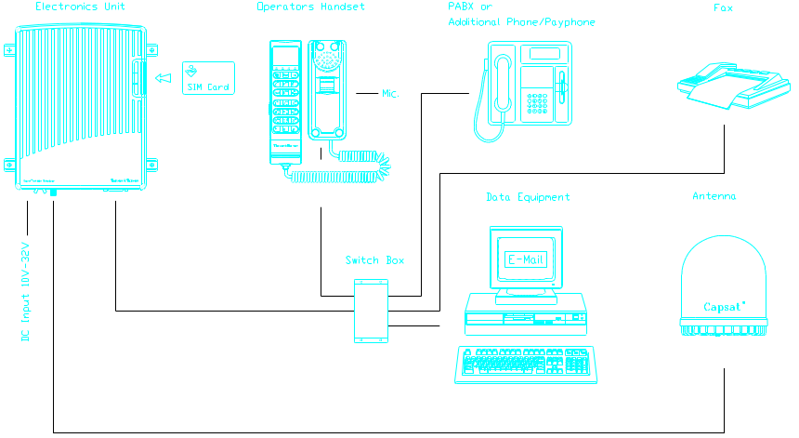
Figure 0-1: Capsat® Mini-M Telephone Configuration
with the TT-3617A Fax/Phone Switch installed.
(shown with the TT-3007D Maritime Antenna)

Installation
When installing or configuring the Fax/Phone Switch, the system must be turned off.

By installing the Fax/Phone Switch, the two-wire connection in the
Cradle Unit is disconnected, and only the “Fax” and “Phone” connection, on the Fax/Phone Switch, is available.
Connect a Phone/PABX/Pay-phone to the connector marked “Phone” and a Fax-machine to “Fax”. Reversing will cause faulty operation.

The TT-3617A Fax/Phone Switch must be installed in a protected dry area. Mounting of the Fax/Phone Switch is performed by using 4 self-tapping screws

The TT-3617A is equipped with a 1 meter cable for the main unit connection. The Cradle is then connected to the 26-pole connector marked “Cradle”.
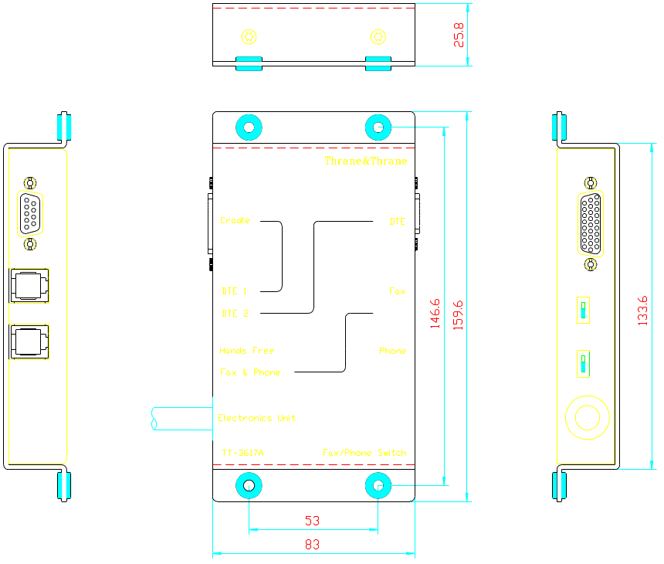
Figure 0-2: TT-3617A Fax/Phone Switch Outline.

Functional Description
The TT-3617A Fax/Phone Switch can be set to operate in different modes. On installation the required mode must be determined, and set by the two switches, located on the left side of the Fax/Phone Switch. The switches are reached though holes, and preferably operated by a pen, a small screwdriver, or similar tool.
The “Fax” and “Phone” connectors are of the standard 6 pole RJ-11 type.

“Fax & Phone/Hands Free” Switch
When Fax & Phone is selected, the system is ready to accept incoming as well as outgoing calls, to both connections. Incoming fax calls are routed directly to the fax machine and phone calls to the additional phone, PABX, or pay-phone.
During the call the non-active line is temporarily disconnected.

When an outgoing phone call is started, the fax line will be temporarily disconnected.
When an outgoing fax call is started, the phone line will be temporarily disconnected.

When Fax & Phone is selected, the Hands Free operation is no longer available i. e. no external microphone can be connected to the Cradle unit.
In the handset the correct settings must be selected. In the Config menu, chose Aux/Fax conf. and Switch

Setting the switch to Hands Free, enables Hands Free operation, and the external microphone and loudspeaker (TT-3624A) can be connected to the Cradle unit/Transceiver.
In the handset the correct setting must be selected. In the Config menu, chose Aux/Fax conf. and select another setting than Switch (Fax, Aux Phone, or None). Hands Free operation is now available.

When choosing Hands Free, switching of the fax and phone lines is disabled. This means that only the “Phone” connection is available, and the “Fax” connector will never be selected.
It is still possible to connect a fax machine (as well as a phone) to the “Phone” connector. Operation is the same as if the TT-3617A Fax/Phone Switch was not installed.

“DTE1/DTE2” Switch
The “DTE1/DTE2” switch selects which DTE connection should be used.
The DTE connection is a serial EIA standard RS-232E I/O port, which provides communication for a serial data terminal. The connector is a 9-pole female Sub-D type.

If DTE1 is selected, the connector in the TT-3622A Cradle unit is selected, and the one in the TT-3617A Fax/Phone Switch is disconnected.
If selecting DTE2, the connector in the TT-3617A is selected, and the one in the Cradle is disconnected.

Only Mini-M transceivers having software ver. 1.13 and forth, will be able to support the TT-3617A Fax/Phone Switch.

Please refer to the Users Manual (Technical Reference) for pin assignment of the DTE and Fax/Phone connectors.

